**Header and Footer**

We can provide Header and Footer content in the SfAutoComplete by enabling ShowDropDownHeaderView and ShowDropDownFooterView.

**Header Content**

We can provide Header Content at the top of the AutoComplete's Suggestion box. DropDownHeaderViewproperty is used to set the content of the header. The following code example illustrate how to set Header content in SfAutoComplete.

List<String> countryList = new List<String>();

countryList.Add ("Uganda");

countryList.Add ("Ukraine");

countryList.Add ("United Arab Emirates");

countryList.Add ("United Kingdom");

countryList.Add ("United States");

ArrayAdapter<String> countryListDataAdapters = new ArrayAdapter<String>(context,Android.Resource.Layout.SimpleListItem1, countryList);

countryAutoComplete.SetAutoCompleteSource(countryListDataAdapters);

countryAutoComplete.SuggestionMode=SuggestionMode.StartsWith;

countryAutoComplete.ShowDropDownHeaderView=true;

TextView textView = new TextView(context);

textView.Text = "Search for U"

textView.setTextColor(Color.parseColor("Blue"));

textView.TextSize = 16;

textView.SetPadding(20, 0, 20, 0);

countryAutoComplete.DropDownHeaderView=textView;

**Header Height**

The height of the Header in the SfAutoComplete can be adjusted by the property DropDownHeaderViewHeight.

List countryList = new List(); countryList.Add ("Uganda"); countryList.Add ("Ukraine"); countryList.Add ("United Arab Emirates"); countryList.Add ("United Kingdom"); countryList.Add ("United States"); ArrayAdapter countryListDataAdapters = new ArrayAdapter(context,Android.Resource.Layout.SimpleListItem1, countryList); countryAutoComplete.SetAutoCompleteSource(countryListDataAdapters); countryAutoComplete.SuggestionMode=SuggestionMode.StartsWith; countryAutoComplete.

//Set the Height of the Header View

DropDownHeaderViewHeight=50;

countryAutoComplete.ShowDropDownHeaderView=true;

TextView textView = new TextView(context);

textView.Text = "Search for U"

textView.setTextColor(Color.parseColor("Blue"));

textView.TextSize = 20;

textView.SetPadding(20, 0, 20, 0);

countryAutoComplete.DropDownHeaderView=textView;

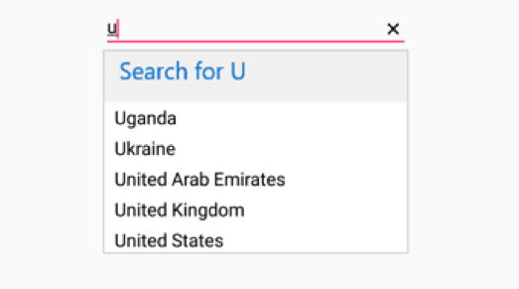

**Footer Content**

We can provide Footer Content at the bottom of the AutoComplete's Suggestion box. DropDownFooterViewproperty is used to set the content of the footer. The following code example illustrate how to set Footer content in SfAutoComplete.

List<String> countryList = new List<String>();

countryList.Add ("Uganda");

countryList.Add ("Ukraine");

countryList.Add ("United Arab Emirates");

countryList.Add ("United Kingdom");

countryList.Add ("United States");

ArrayAdapter<String> countryListDataAdapters = new ArrayAdapter<String>(context,Android.Resource.Layout.SimpleListItem1, countryList);

countryAutoComplete.SetAutoCompleteSource(countryListDataAdapters);

countryAutoComplete.ShowDropDownFooterView=true;

TextView textView = new TextView(context);

textView.Text = "Add New"

textView.TextSize = 20;

textView.setTextColor(Color.parseColor("Blue"));

textView.SetPadding(20, 0, 20, 0);

countryAutoComplete.DropDownFooterView=textView;

{

**Footer Height**

The height of the Header in the SfAutoComplete can be adjusted by the property DropDownFooterViewHeight.

List countryList = new List(); countryList.Add ("Uganda"); countryList.Add ("Ukraine"); countryList.Add ("United Arab Emirates"); countryList.Add ("United Kingdom"); countryList.Add ("United States"); ArrayAdapter countryListDataAdapters = new ArrayAdapter(context,Android.Resource.Layout.SimpleListItem1, countryList); countryAutoComplete.SetAutoCompleteSource(countryListDataAdapters);

//Set the Height of the Footer View

countryAutoComplete.DropDownFooterViewHeight= 50;

TextView textView = new TextView(context);

textView.Text = "Add New"

textView.setTextColor(Color.parseColor("Blue"));

textView.TextSize = 20;

textView.SetPadding(20, 0, 20, 0);

countryAutoComplete.DropDownFooterView=textView;

